**INITIAL DESIGN**

This chapter explores the initial design stages and thought processes within the group. The Paper Prototype stage is treated as a separate chapter as lessons from that greatly influenced the design process downstream of its creation.

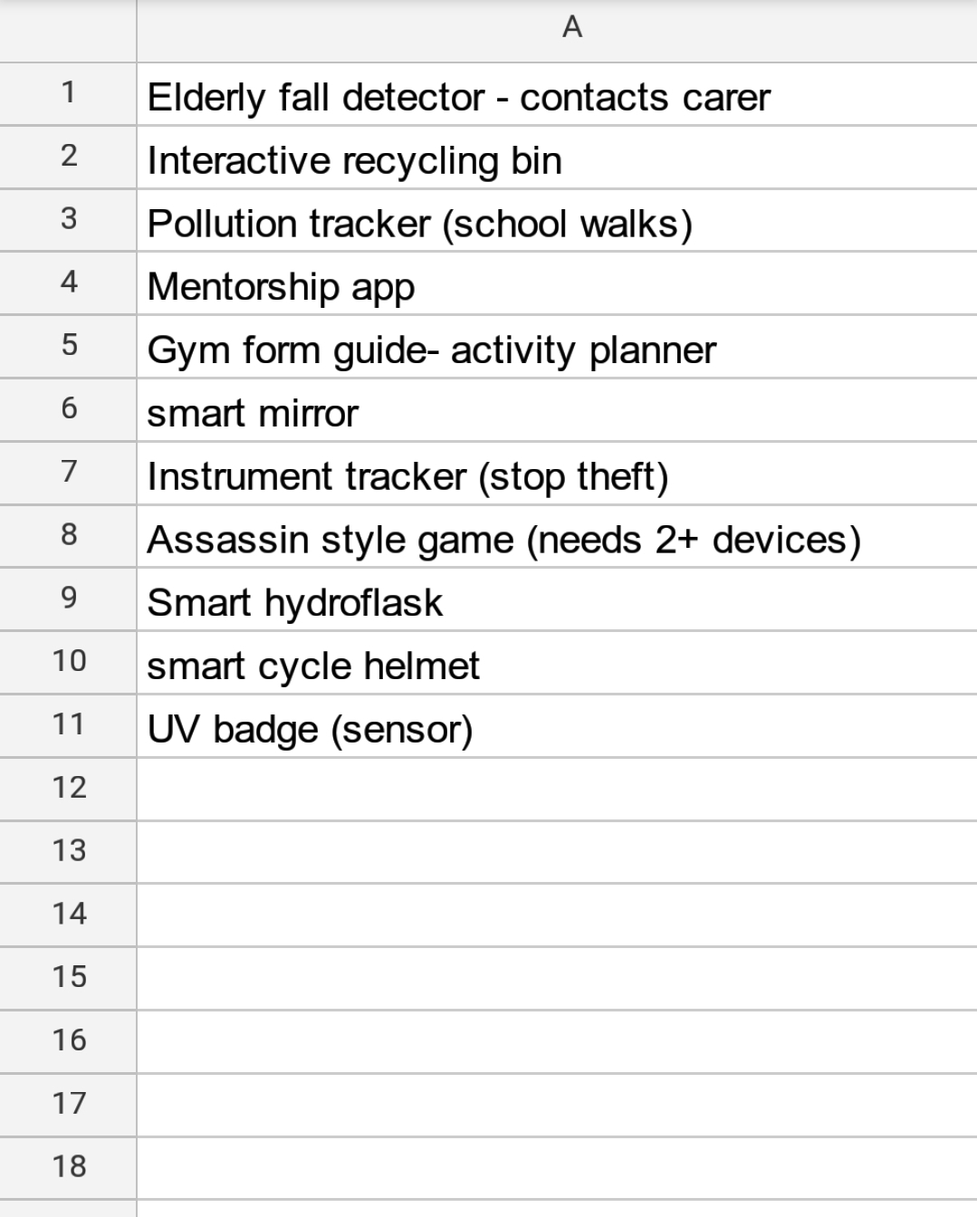At the earliest stage of the group project, a Google Sheet was created and shared with all the members (see fig 1).

This allowed each individual to suggest and list projects. Following this a group meeting was held to discuss the various suggestions, and a decision was made to explore the Cycling Hemet concept as its offered a useful safety function to a wide proportion of society.

It also offered a suitably modular development, perfect for OOP, allowing new programmes or apps to be added to the core design at a later stage. Indeed, it was realised that some of the other projects listed be incorporated into the Cycling Helmet app (e.g. a pollution tracker, or a smart hydroflask that reminded you to hydrate yourself at set intervals).

Figure 1: Google Sheet list of potential projects.

The Google Sheet and meeting where held and devised priot to the Ideation workgroup session. However the spitballing of ideas created an environment where no idea was off the table, and created a wider sense of what the project could encompass. Figure 2 (overleaf) is an image from that Ideation session of various non-related ideas, but demonstrates the creative freedom the session created.

From an initial idea of a helmet that had indicator and break lights, we expanded to include a fall detector, a route map, the ability to track your cycling progress, calculate calories burnt, best ride times, and an option to challenge your cycling friends to beat your times. Whilst not all of these could be explored within the paper prototype at the workshop, the basic concept and user experience was explored.

A further development was the realisation that building a device that could be used on any cycling helmet offered a greater prospect of a successful business plan, as now the potential purchaser was adding value to their existing equipment instead of replacing it.

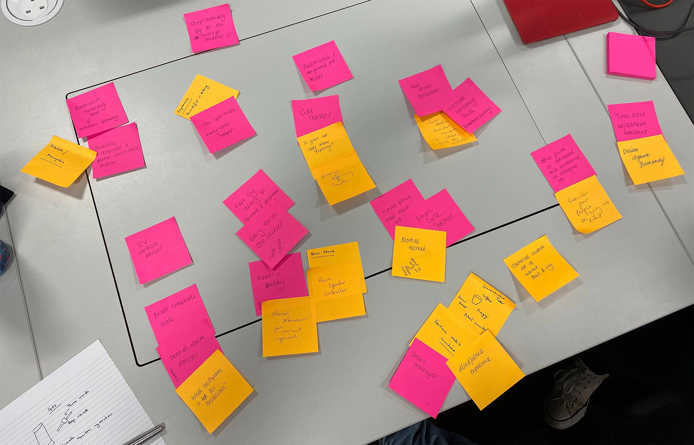

Figure 2: Ideation workgroup session

Following these sessions a basic schematic was drawn up (fig 3). At this stage the group was working on a system that only incorporated a M5 Stack and a web app that could be used on a mobile device. This would change as the brief for the project was expanded upon in lectures and lab sessions.

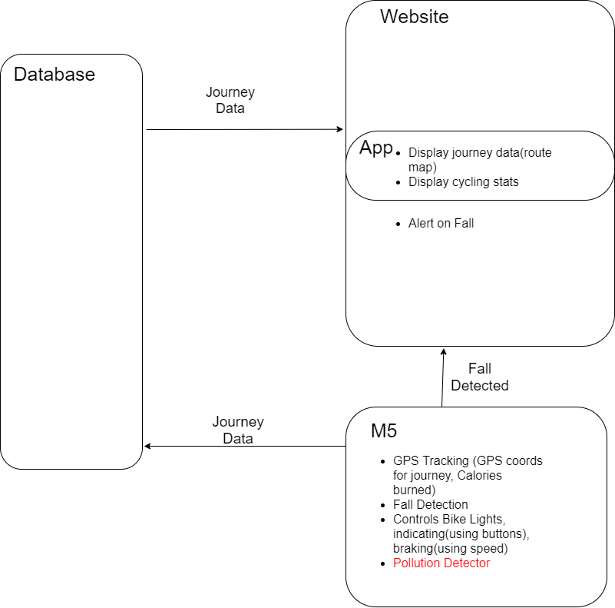Figure 3: Early schematic of the system

With the concept taking shape, and with the brief now at its most advanced stage, the group booked MVB 2.59 on 27th February 2020 to incorporate all aspects. Figure 4 shows the a composite image of the whiteboard from that meeting.

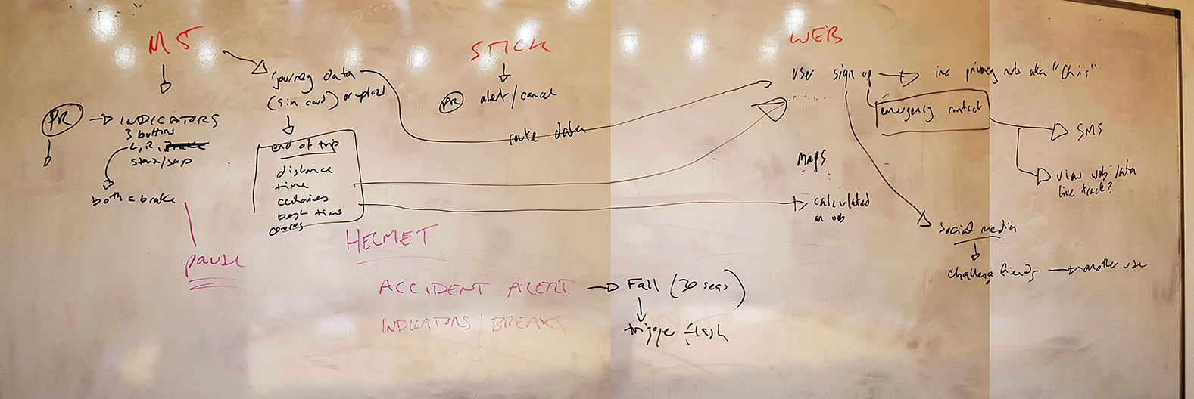Figure 4: Whiteboard from meeting 27 Feb 2020, MVB 2.59

The project now incorporated (i) the M5 Stack – running electronic signals to the lighting system on the helmet (note, this would be later all be installed within a self contained unit on the helmet) and sending data to (ii) web based database/app, that in return could send trip data back to the stack for display, and (iii) the M5 Stick which could start/stop fall alerts.

This was further explored and broken down using UML alongside visulaistaions of what various users could expect (see figs 5 and 6). Here we see the beginnings of the fall alert system, allowing interested parties (parent or significant other) to follow the cyclists route and be alerted in the event of a fall, as well as the emergency services and local authority who may use the data to provide safer transit for cyclists through a city.

At this stage note the project name is CyberDome. Guardian Cycle would come at a later stage.

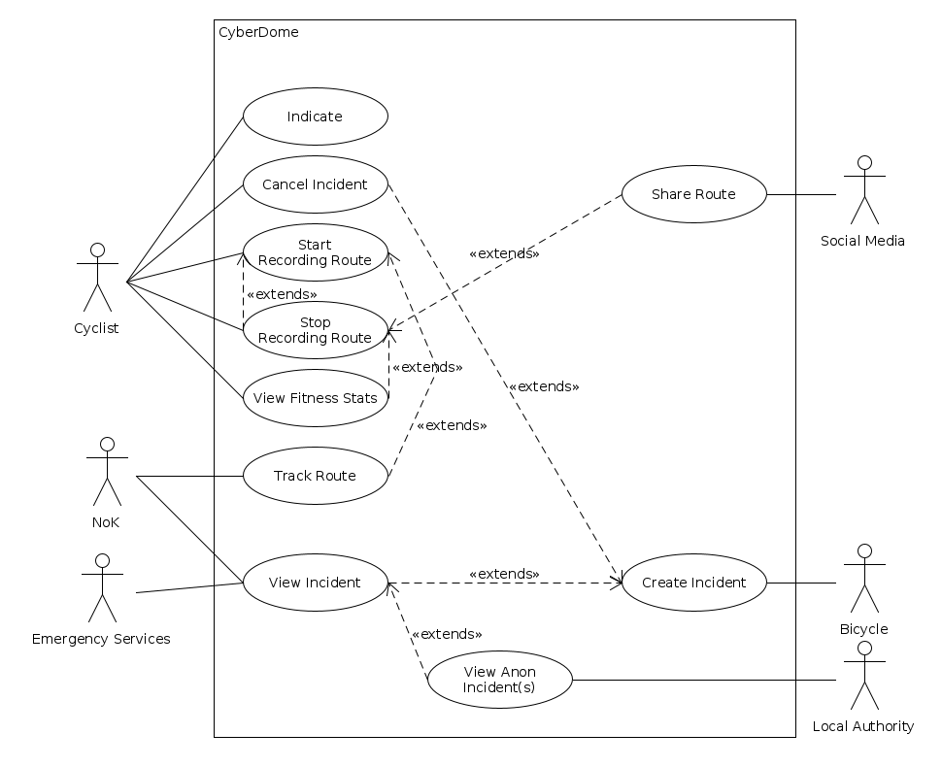Fig 5: Various End User expectations from the system

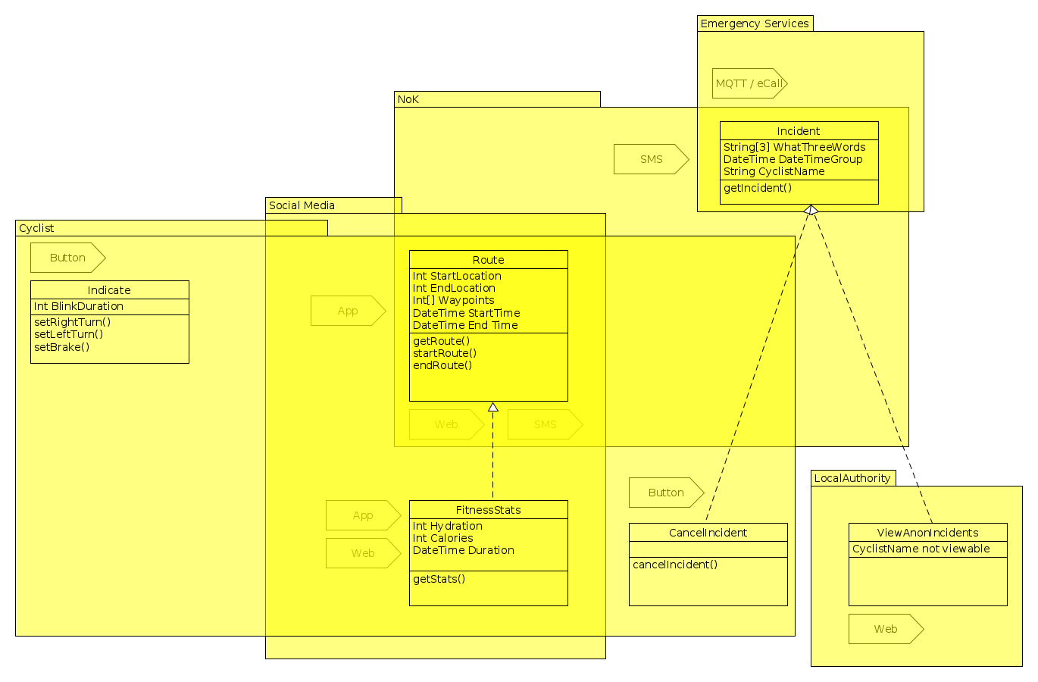

Figure 6: UML diagram for Guardian Cycle.